Exercise 1
Here is a small paragraph written critically evaluating a research paper. Read it carefully. Notice the content, language and how it is used.
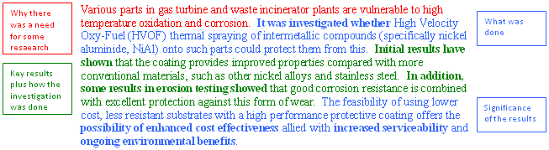
Exercise 2
Given below are three critical reviews that have been synthesized to develop the Literature Review section of a research project. Read them carefully and fill the blanks with the appropriate form of the given in brackets.
- In a study by Das, K.P.L, and Labove, J, a system to automatically diagnose diabetes using OCT images ____________(develop). The system is used to find diseases Diabetic Retinopathy and Glaucoma. Detection of the Glaucoma is done by guessing the thickness of the Retinal Nerve Fibre Layer from the OCT image. This is done based on deformable snake algorithm to segment anterior and posterior boundaries. The system _______________(test) 31 OCT images of patients out of which 13 were found to be glaucomatous. The accuracy of finding optical disk is 97.75%. In this scenario they only use 13 fundus images to check the algorithm. Since the researchers _____________(use) different algorithms without calculating CDR, this system does not work for all types of images.
- In a similar system, Glaucoma _________________ (identify) using a combination of magnitude and phase features from the digital fundus image. For both magnitude and phase components, the histogram features ______________(compute). ….. The system results 95.45% output for sensitivity, specificity and classification. Here this system only ____________(detect) features and did not calculate CDR. This system was developed using a pre-defined value for all images. Though the values ___________(suit) their tested images, it is not applicable for all types of images. Hence, the value can be considered a variable.
- In the paper” Super Pixel Classification” a self assessment reliability score ___________(compute) to evaluate the quality of the automated optic disk segmentation. This study __________(focus) on CDR measurement of the 2D fundus image. This system was mainly based on mathematical morphology with PCA in preprocessing step. Experimental results show an average overlapping error of 9.5% and 24.1% in optic disk and optic cup segmentation, respectively.

